ASSESSMENT-01

1.Creating a virtual machine with availability set using the custom image with chrome preinstalled.

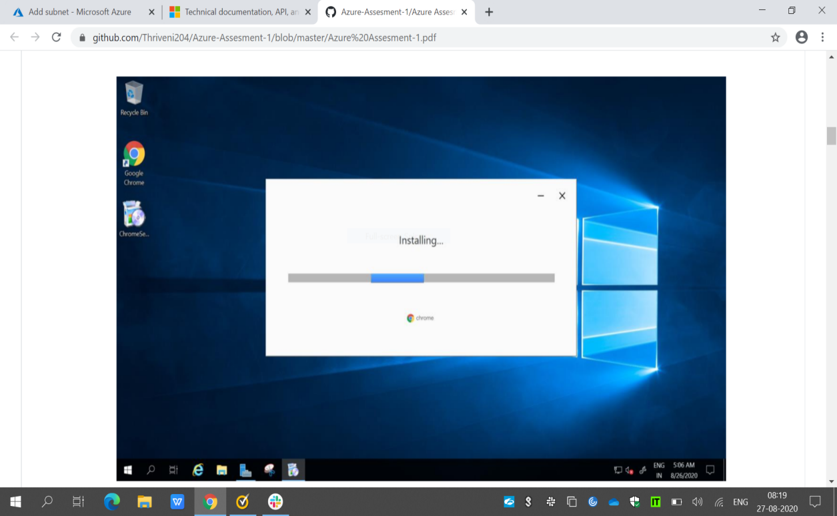

2.Creating a Virtual Machine scale set with Ds1-v2 standard.

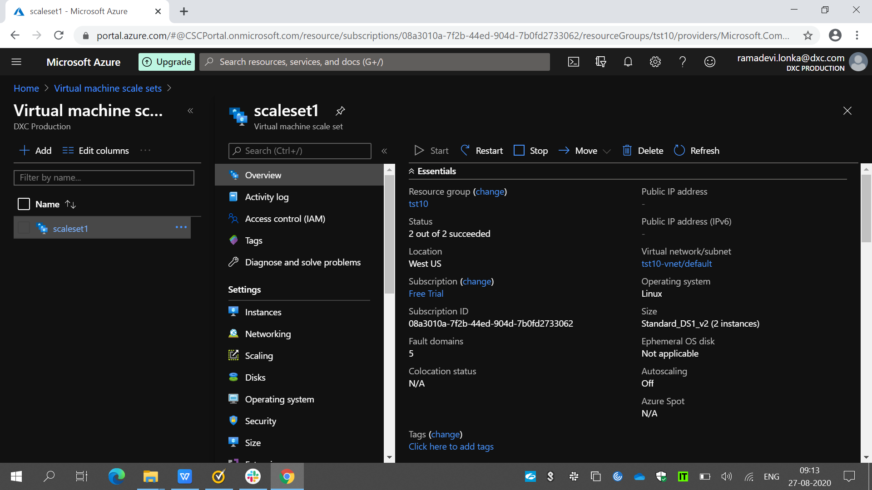

3.Creating a blob storage account with GRS standard and enable the blob soft delete with 15 days retention period and also it should be connected to azure storage explorer.

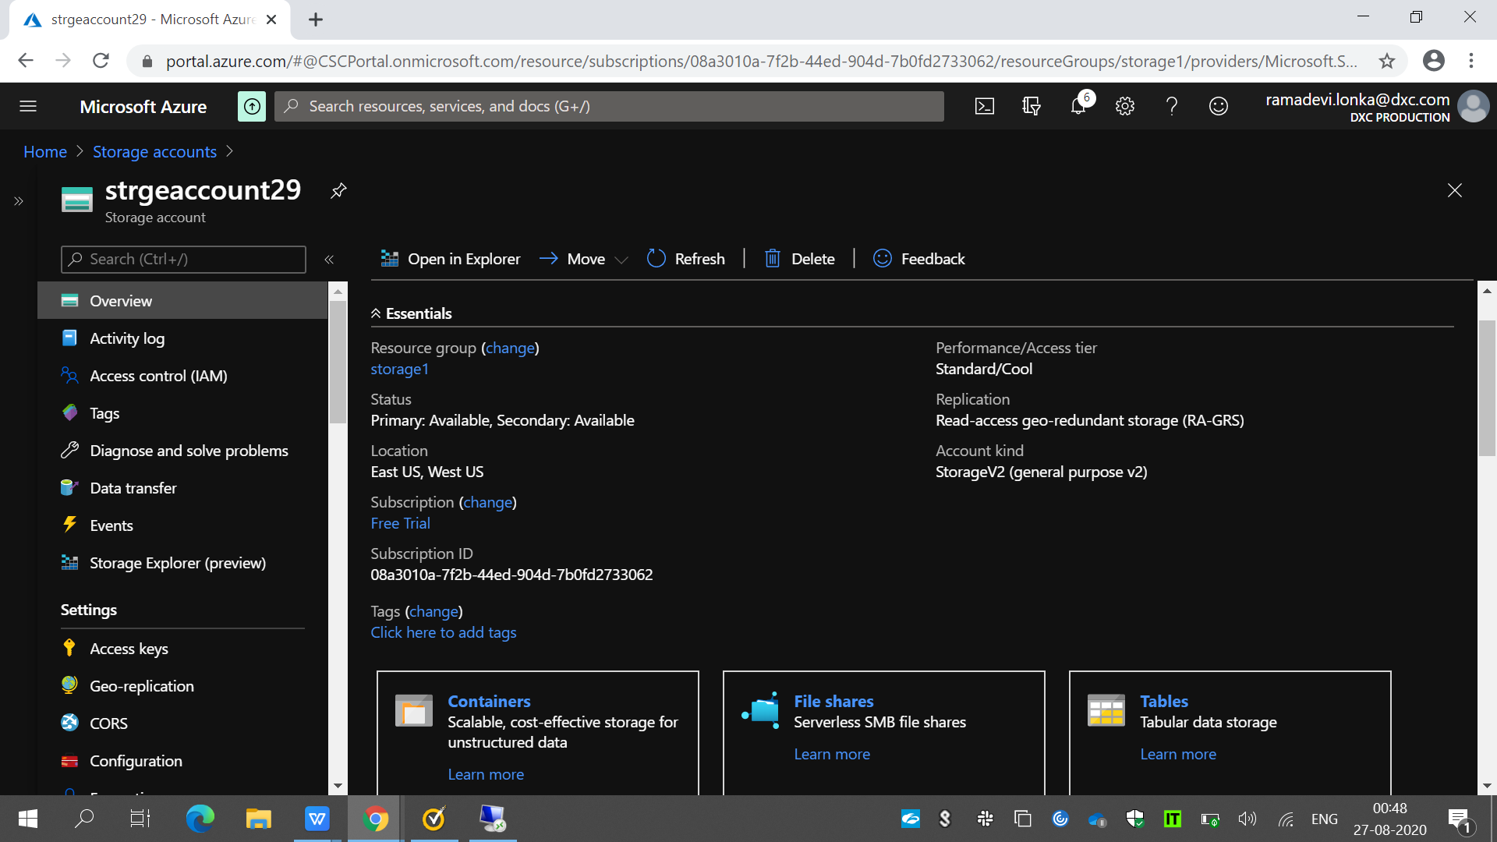

1. Configuring the Vnet and creating the 3 subnets in the Vnet.

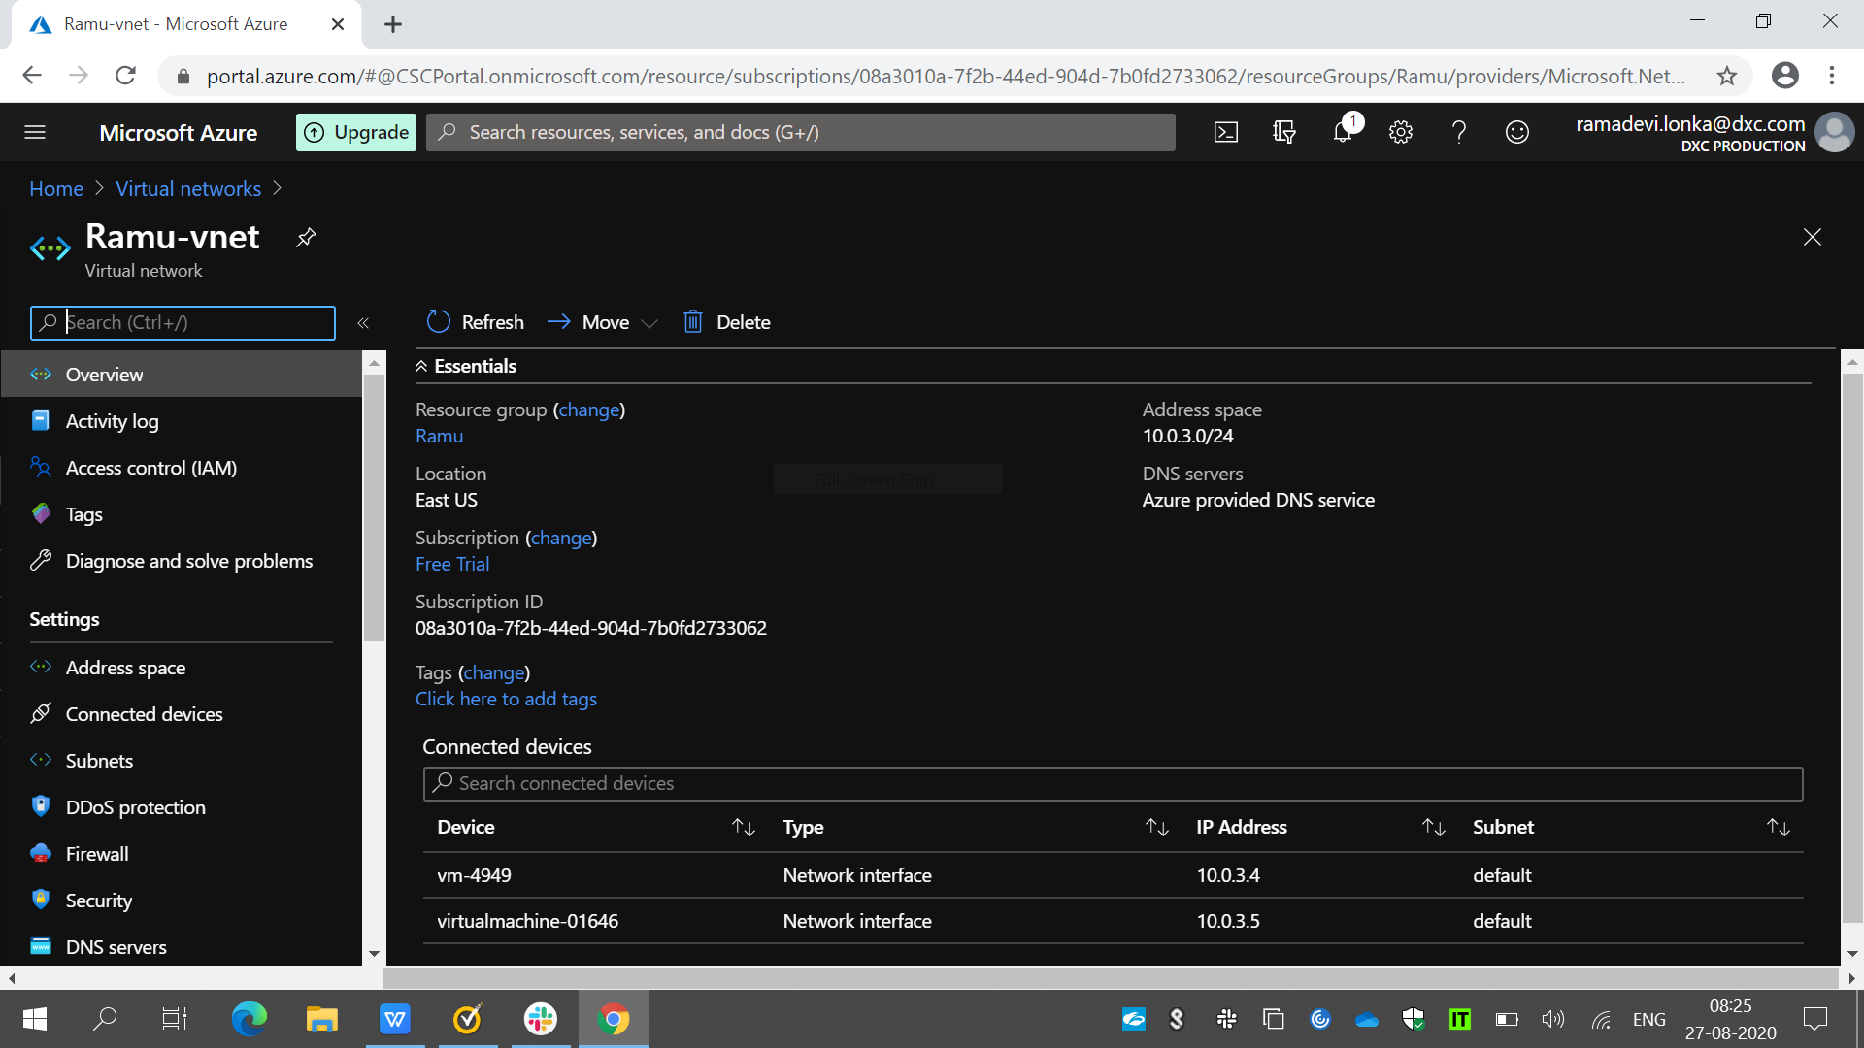

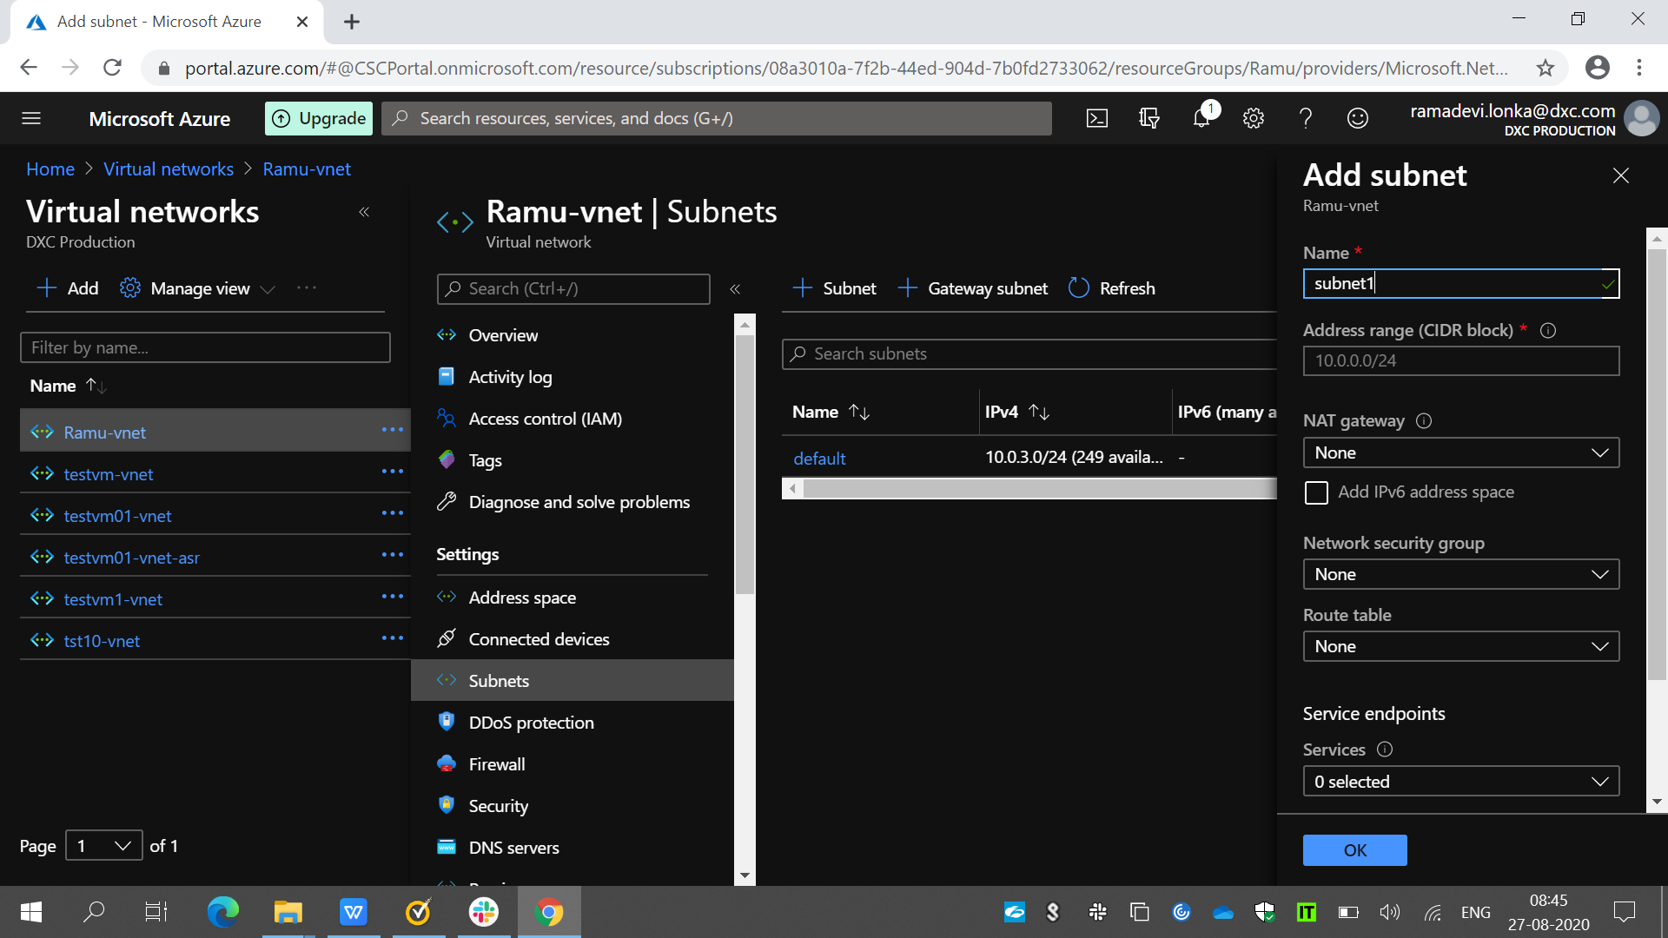

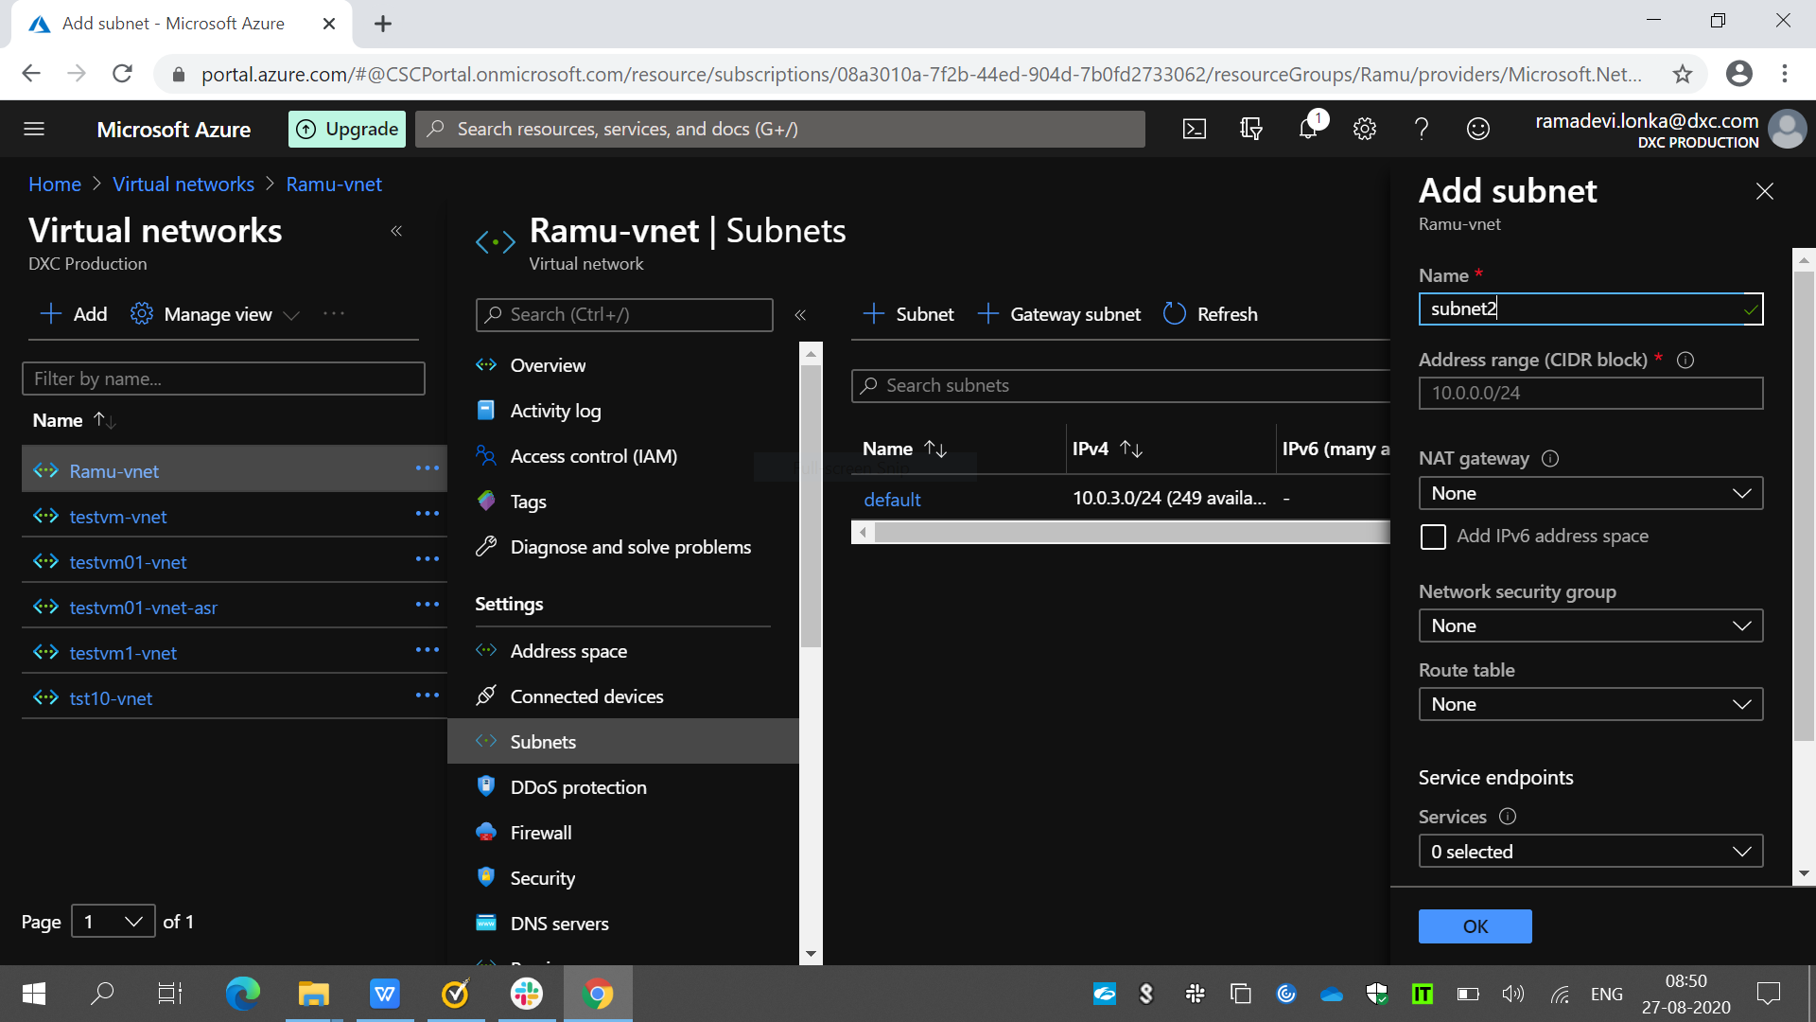

5.Creating the traffic manager with performance routing method.